Customer Problem Statement
Buying airline tickets online is frustrating and stressful for me. When I want to book a flight, I usually have to check multiple airline websites just to compare prices, times, and seat options. A lot of these systems feel cluttered, and they don’t clearly show the full cost until the very end. This makes the process confusing and time-consuming, and sometimes I just give up before finishing the purchase. I expect a software system to let me search, compare, and book flights in one place without surprises, so I can quickly find a flight that works for my schedule and budget.

Glossary of Terms
- Flight Search – The feature that lets users look up flights using city names, dates, and number of passengers.
- Booking – The process of selecting a flight, entering passenger information, and purchasing a ticket.
- Seat Selection – Choosing a specific seat on a flight before completing the purchase.
- Ticket – A digital confirmation that proves a flight has been booked and paid for.
- User Account – A personal profile where users can store their booking reminders and manage tickets.

System Requirements
Functional Requirements

No. | Priority Weight | Description
REQ-1 | High | The system should allow users to search for flights using city names, dates, and number of passengers.
REQ-2 | High | The system should display available flights with prices and schedules.
REQ-3 | High | Users should be able to compare flights in one place.
REQ-4 | Medium | The system should allow users to select seats before purchase.
REQ-5 | High | Users should be able to enter passenger and payment information securely.
REQ-6 | High | The system should allow users to complete ticket purchases online.
REQ-7 | Medium | Users should be able to view or manage their booked tickets later.

Nonfunctional Requirements (FURPS)
Category | Priority | Description
Functionality | High | All major booking features must work correctly without errors.
Usability | High | The system should be easy to understand and navigate for first-time users.
Reliability | Medium | The system should store booking data accurately and consistently.
Performance | Medium | Flight searches and bookings should load quickly.
Supportability | Low | The system should be easy to update or fix if issues occur.

User Interface Requirements
- Flight Search Page (High Priority)
A simple page where users enter departure city, destination, dates, and number of passengers.
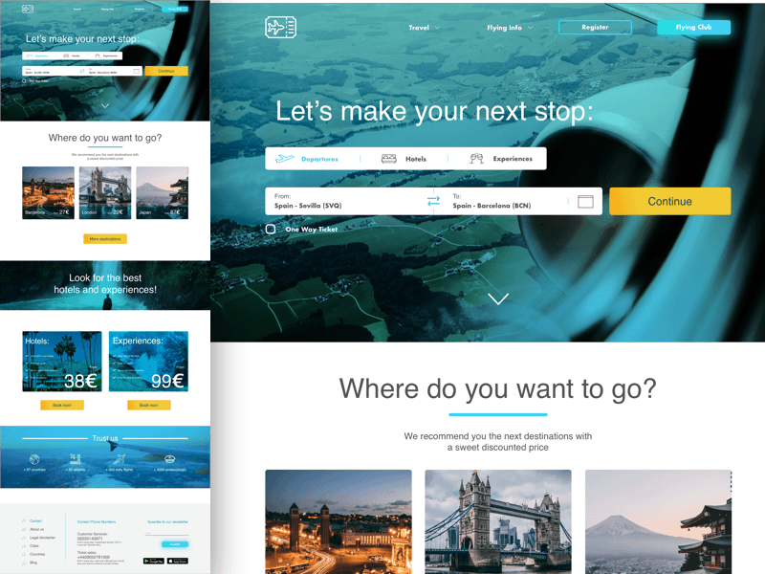
Flight Search Code Draft
[ From City ] [ To City ]
[ Date ] [ Passengers ]
[ Search Flights ]
- Search Results Page (High Priority)
Displays a list of available flights with prices, times, and airlines in a clear layout.
- Seat Selection Page (Medium Priority)
Allows users to pick seats before paying.
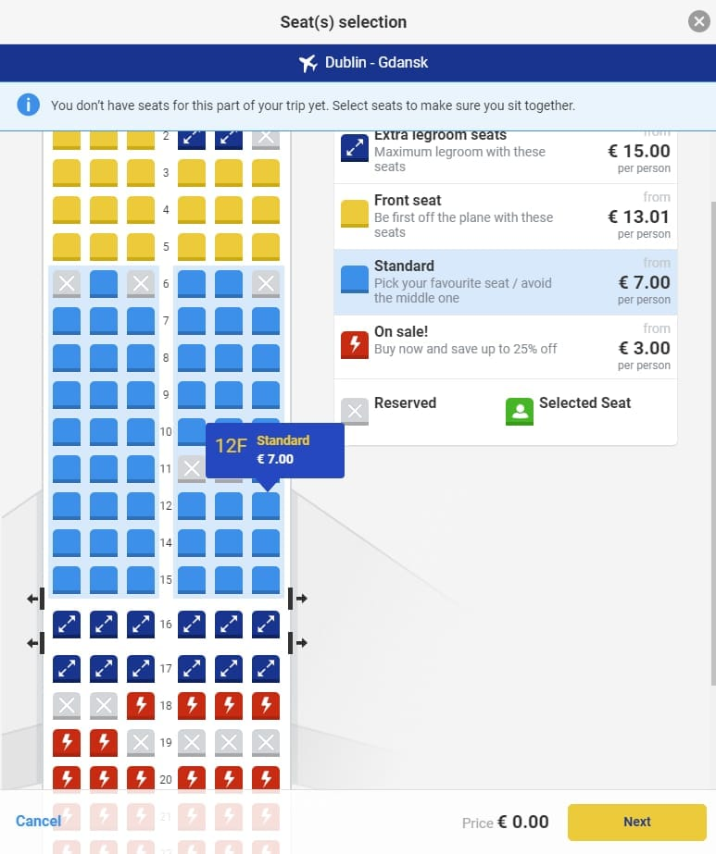
- Checkout Page (High Priority)
A clean screen to enter passenger details, payment information, and confirm the booking.
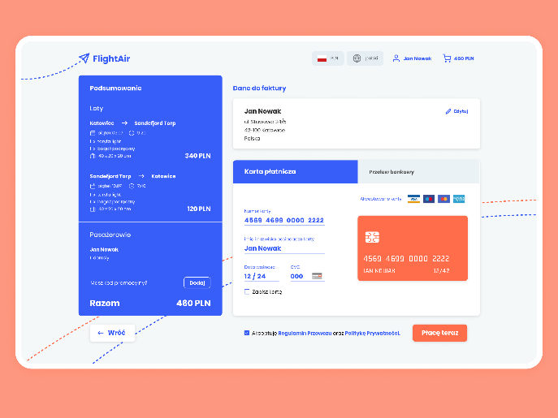

Plan of Work
So far, I have finished defining the problem and system goals based on my proposal. I have clearly identified user needs and listed the main system requirements. Right now, the focus is on organizing requirements and planning the system structure before moving into design and development.

References
*These images are used as illustrative examples to represent common airline booking interfaces and were not taken from a specific proprietary system.

Google Images. (n.d.). Airline flight search interface examples. Retrieved from https://www.google.com/images

Google Images. (n.d.). Flight search results and price comparison interfaces. Retrieved from https://www.google.com/images

Spring boot. (n.d.). Spring Boot. https://spring.io/projects/spring-boot

Tilley, S., & Rosenblatt, H. (2017). Systems analysis and design (11th ed). Boston, MA: Cengage

Trawex.com. (n.d.). Flight Booking software | Airline Ticket Software | GDS System. https://www.trawex.com/flight-booking-software.php

Verkalets, I. (2025, November 23). 10 best flight booking solutions in 2026. COAX Software. https://coaxsoft.com/blog/10-best-flight-booking-solutions

